**Test 2**

**Attempt ALL Questions:**

**Q.N.1**

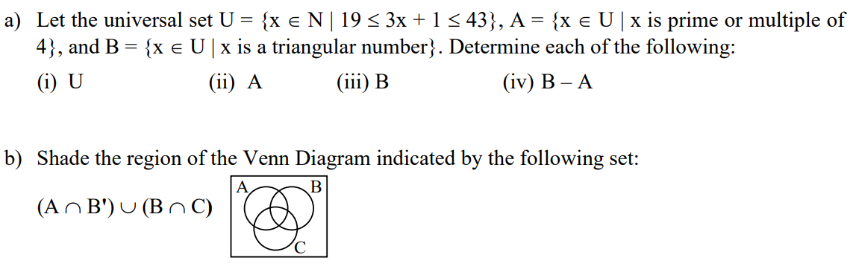

c. If universal set U = {1, 2, 3… 10} and its subsets are A = {x: $x^{2}-3x+2=0,x∈z^{+}$}, B = {factors of 4} and C ={x: x $≤6$} then,

i. Find (A $∩$ B $∩$ C)

ii. List the elements of set ${(A∪B∪C)}^{c}$

iii. List the elements of A $∆B$

iv. Draw a Venn diagram and shade the portion represented by A $∩$ B $∩$ C, ${\left(A∪B∪C\right)}^{c},$ A $∆B$

d. Use a hybrid truth/membership table to prove $\overline{\left(A∪B\right)}=\overline{A} ∩\overline{B}$

Q.N.2

Let A= {1, 2, 3} and B ={a, b, c} b and C = {x, y, z}then consider R:A $→B$ ={(1, b), (2, a), (2, c)} and S :B $→C$ = {(a, y),(b, x),(c, y),(c, z)}.Then,

1. Find $R^{-1}$
2. Find domain, codomain and range of relation R
3. Find the composition of SoR
4. Show the relation R on arrow diagram, matrix form and directed graph.
5. Find $M_{R } ,M_{S} and M_{S0R}$ and compare $M_{R }.M_{S} and$ $M_{S0R}$.

Q.N.3

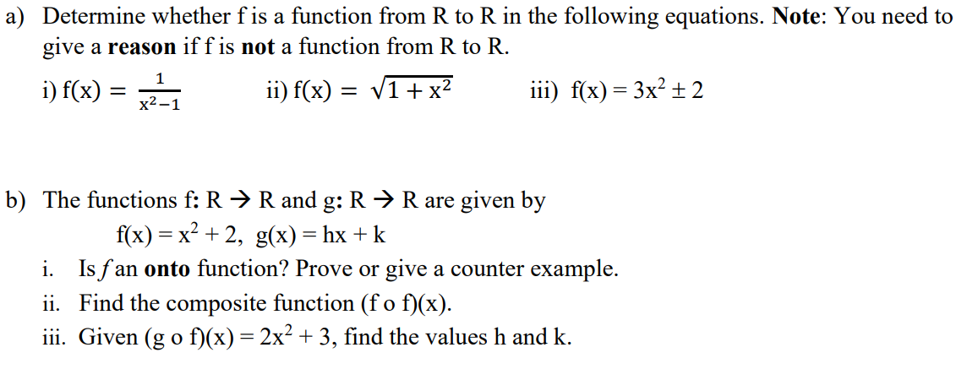

c) Define relational Database. Why it is more important than other types of database explain with suitable examples.

**Q.N.4**

a.

i. Find the GCD of (33245, 325) by using Euclidean Algorit

ii. Construct addition and multiplication modulo 6.

iii. Calculate: ${75}^{45}$ in Z103

iv. Solve: 25x = 10 (mod10)

b. Messages are to be encoded using the RSA method, and the primes chosen are 13 and 17.Encode and decode the numbers 21.

*The End*